Packages

A package is a container of a group of related classes where some of the classes are accessible are exposed and others are kept for internal purposes. We can reuse existing classes from the packages as many times as we need it in our program.

Import Statement

Import statement in Java is helpful to take a class or all classes visible for a program specified under a package, with the help of a single statement.

Example:

Class Greeting

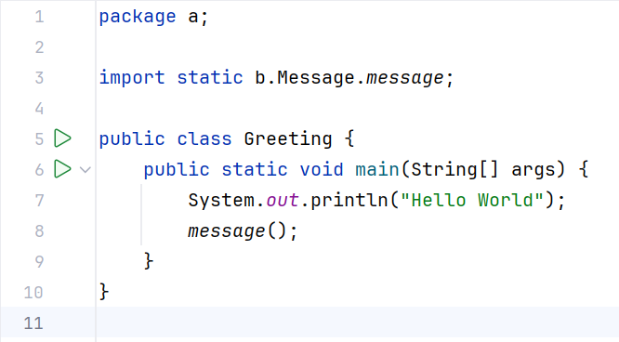

Class Message:

STATIC IN JAVA

The properties or methods that are not directly related to objects are static variables or methods but are common to all the objects of the class are known as Static.

Example: In the Human Class, population is not related to any object of Human class and is common for every Human, therefore, we declare that as **`static`.**

In order to access static variables, we must use Class Name and not by this keyword because this keyword is used for objects and static variables are not related to objects.

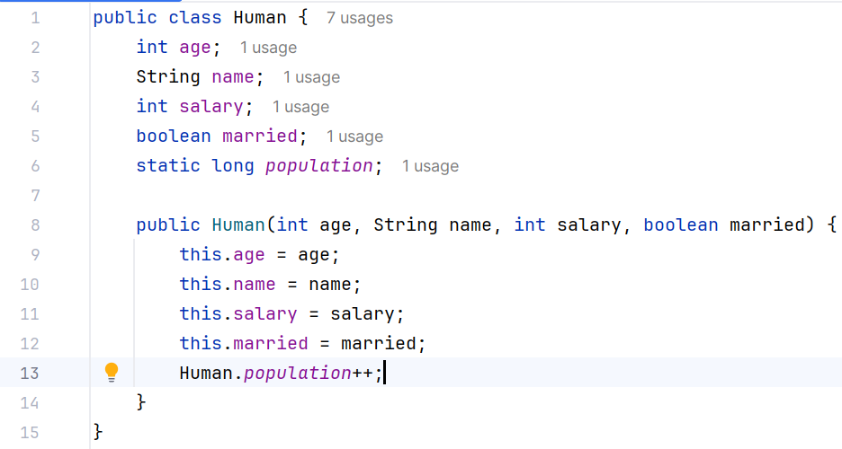

STATIC VARIABLE

* When a member is declared static, it can be accessed before any of the objects of the class is being created and without referencing that object. We can access them by the class Name.
* You can declare both the members and the methods as static.
* Non-static members cannot be accessed by static members. Therefore, static methods can only access static data.
* But we can access static data inside non-static methods.

WHY IS MAIN METHOD STATIC?

The main() method is marked static so that the JVM may call it without having to create an instance of the class that contains the main() function. Since no class object exists when the java runtime starts, we must declare the main() function static.

STATIC METHODS

We cannot use **this** keywordinside static method because this is related to objects.

STATIC BLOCK

* In simpler language whenever we use a static keyword and associate it to a block then that block is referred to as a static block. Unlike C++, Java supports a special block, called a static block (also called static clause) that can be used for static initialization of a class. This code inside the static block is executed only once: the first time the class is loaded into memory.
* There is no specified way static block executes automatically when the class is loaded in memory.

Inner Classes

Inner class refers to the class that is declared inside class or interface which were mainly introduced. To sum up, the same logically relatable classes as Java are purely object-oriented so bringing it closer to the real world.

There are certain advantages associated with inner classes are as follows:

* Making code clean and readable.
* Private methods of the outer class can be accessed, so bringing a new dimension and making it closer to the real world.
* Optimizing the code module